SRI LANKA

Sri Lanka, the tourist literature will tell you, is "a land like no other", and this is no idle boast. Lying just off the south-east coast of India, with its southern tip barely 30km from the equator this is a tropical island that for centuries has attracted the covetous gazes of people from all over the world. Rightly it deserves its earlier appellation as "pearl of the orient".
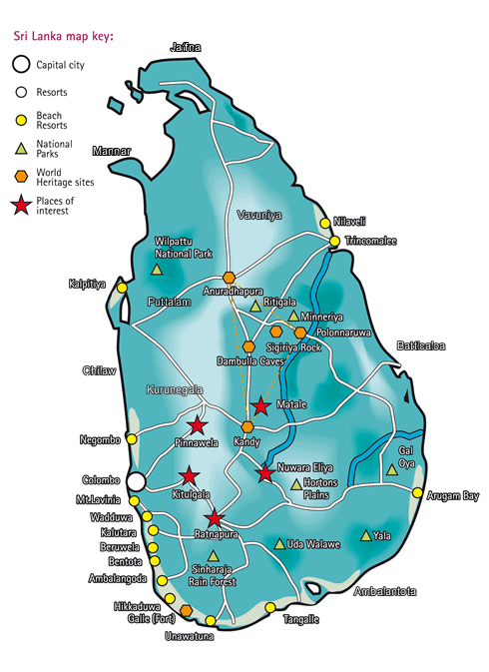

VISA REQUIREMENTS: Visa is issued on arrival for Indian Passport holders
Please note above are the standard documents that the Consulate usually ask for, in case they require any more documents or clarifications we shall let you know. Please bear with us as we have no control on the requirements for the Visas.

LANGUAGES:
The two official languages in Sri Lanka are Sinhala and Tamil. However, English is widely spoken in important tourist centers

TIME ZONE: Same as IST

HOW TO GET THERE:
By Air: Sri Lankan (UL), Indian Airlines (IC), Jet Airways (9W) fly directly into Colombo.
Most International Carriers like Emirates, Cathay Pacific, Thai Airways, Singapore Airlines etc fly into Colombo etc.

CURRENCY:
Srilankan Rupees
The US and Australian Dollars, Yen and British Pound are also accepted in the larger shopping centres. In large shops, particularly the roadside arts and craft centres that serve the passing tourist trade, you should have no problem using international credit or debit cards. American Express, MasterCard and Visa are the most commonly recognised cards, and any debit card with a visa facility will usually be accepted. Traveller’s cheques can be cashed at banks or licensed moneychangers and at selected hotels. Banks are open daily, but some do not do foreign exchange on Saturdays. Indian Rupees is also widely accepted in this Island nation.

Tipping is a way of life in Sri Lanka. It is advisable to obtain a bundle of small denomination notes as soon as possible for the purposes of handing to waiting staff, hotel porters and the like.

CLIMATE:
Due to its proximity to equator Sri Lanka has typically tropical climate. There are no marked seasons. The weather in plains and the coastal areas is hot and humid with an average mean temperature of 27° C. Relative Humidity varies from 70% during the day to 90% at night. The cooling sea breeze moderates the temperature. The hills are cool and pleasant with an average mean temperature of around 20° C.

Sri Lanka is blessed with abundant rainfall. The south-west monsoon brings rain mainly from May to July to the western, southern and central regions of the island, while the north-east monsoon causes rains in the northern and eastern regions in December and January.

Best Time to Visit Sri Lanka
Best time to travel to Sri Lanka is between the main rainy seasons. The period from November to April is the driest season on the south west coast and up in the hills. Here, some of the best beaches and many other places of tourist interest are located. Therefore, period between November and April is the best time to visit this region and this period is also considered as tourist season in Srilanka. May to September is the best time to visit east coast, as it is dry during this period. Hence, Sri Lanka is round-the-year destination-there is always a good time to visit at least some part of the country.

CLOTHING:

ELECTRICITY: The electrical current is 240 Volts, AC 50 Hz.
Since voltage tends to fluctuate quite often in Sri Lanka, it is safer to bring a stabiliser if you are going to be using sensitive electronic equipment. Two and three pin round plugs are used widely. However adapters are readily available at electrical stores. In case you lose your adapter or forget to bring it, you could even have a local electrician attach a new plug.

Distances between important places in Kilometres:
City | Col | Kan | Anu | Dam | Gal | Nuw | Pol | Rat | Tri
Colombo | • | 116 | 206 | 148 | 116 | 180 | 216 | 101 | 257
Kandy | 116 | • | 138 | 72 | 232 | 77 | 140 | 142 | 182
Anuradhapura | 206 | 138 | • | 66 | 322 | 216 | 101 | 240 | 106
Dambulla | 148 | 72 | 66 | • | 264 | 150 | 68 | 174 | 109
Galle | 116 | 232 | 322 | 264 | • | 290 | 332 | 150 | 373
Nuwara Eliya | 180 | 77 | 216 | 150 | 290 | • | 217 | 148 | 259
Polonnaruwa | 216 | 140 | 101 | 68 | 332 | 217 | • | 241 | 129
Ratnapura | 101 | 142 | 240 | 174 | 150 | 148 | 241 | • | 283
Trincomlaee | 257 | 182 | 106 | 109 | 373 | 259 | 129 | 283 | •

MUST SEES:

ANURADHAPURA
The ancient city of Anuradhapura was the first capital of Sri Lanka. Founded in 500BC it saw the reign of 103 kings before the capital was moved to Pollunawara in 1073. Nowadays a sprawling complex of ruins it still contains several important Buddhist sites and remains a place of pilgrimage for Sri Lankans.

The holiest site is the Sri Maha Bodhi, the sacred bo tree. Grown from a sapling brought to Sri Lanka by Sanghmitra, sister to Mahinda, it is the oldest documented tree in the world at some 2,200 years. The Great Stupa nearby is one of the largest in Sri Lanka still in good condition, and includes a small temple containing several statues depicting the various incarnations of Buddha. Between the bo tree and the stupa you pass the remains of the Brazen Palace - now only 1600 stone columns stand where there was once a seven-storey, 1,000 roomed building, the largest building in the world of its time.

Elsewhere in Anuradhapura you can see the remains of King Mahasen's Palace with its well-preserved moonstone, the twin ponds where monks used to wash and bathe and Thuparamaya, Sri Lanka's oldest dagoba and believed to contain the shoulder bone of the Lord Buddha. Jetavanaramaya is also worth seeing - the largest stupa on the island its dimensions make it the second biggest monument in the world behind the Great Pyramid at Giza. North-central Sri Lanka.

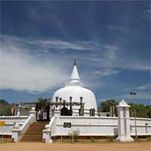
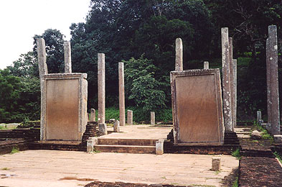

MIHINTALE
Near to Anuradhapura is Mihintale, where Mahinda - the son of the Indian king - first met the Sri Lankan monarch, and thereby brought Buddhism to Sri Lanka. Built around a small hill at the base are the ruins of the monastery that was built here in honour of the auspicious occasion. Interesting sights here include the massive stone trough that used to contain rice and food for over a thousand monks and the lion statue shower, where the monks washed. You can also still see the stone tablets inscribed with the rules and regulations of the monastery for both monks and non-monks.

Further up the hill you find the Cobra Pool, the bathing and recreation pool the monks used. On the shoulder of the hill is a large stupa, while on the saddle you'll find a small monument depicting the exact spot that Mahinda and the king are thought to have met. If you have a head for heights you can climb the narrow, barely-there steps to the top of the rocky outcrop that forms the summit. This hill is known as "the rock of invitation" from where the novice Sumana invited people to come and hear the first sermon of Mahinda. Views from the top looking back to Anuradhapura are well worth the climb.

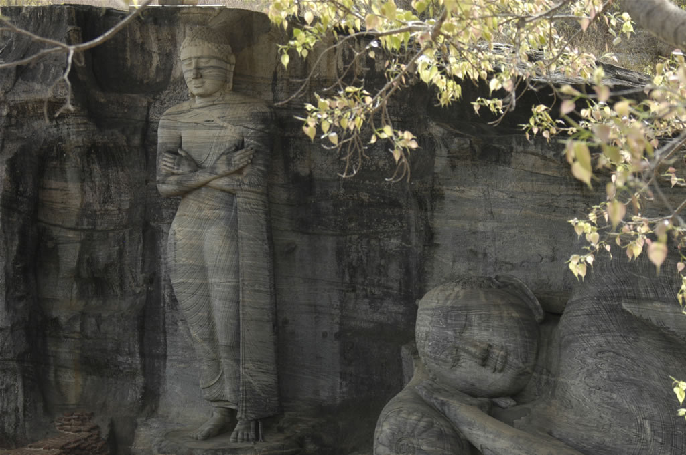
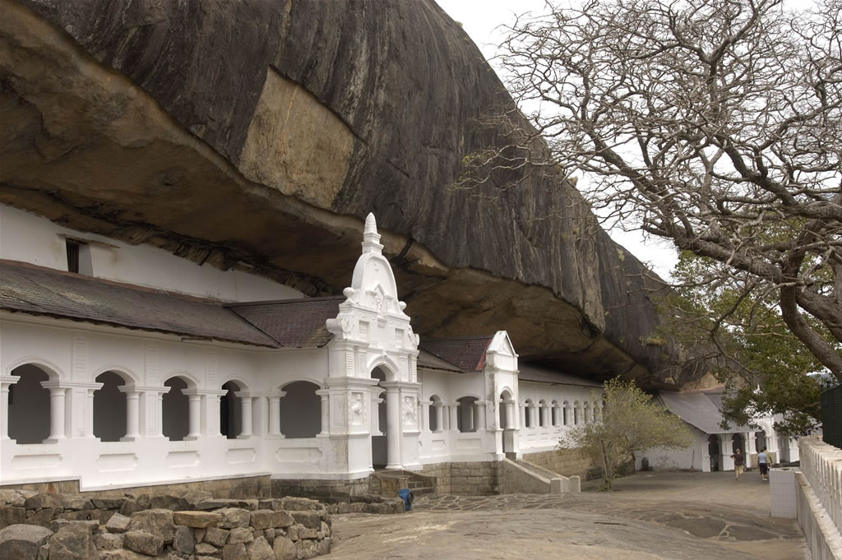

POLONNARUWA
The second capital of Sri Lanka, Polonnaruwa is a lot younger than Anuradhapura and contains better preserved relics. The city was Sri Lanka's capital for only 200 years or so, from the 11th to the 13th centuries, but possessed a marvellous collection of palaces, temples and statuary - much of which still stands today.

It takes a full day to see all the sights that Polonnaruwa has to offer but the undoubted highlights for most people are the marvellous Buddha statues carved from the cliff face at Galvehera. Also known as the "Cave of the Spirits of Knowledge" the three statues of Buddha, one standing, one meditating and one reclining, are amazing examples of the ancient art of stone carving.

Other sites you should visit in the area include the Royal Palace of King Parakramabahu I, one of the first rulers in the 11th century. The outer walls of the main hall still remain standing, although the wooden upper-storeys have long since crumbled to dust. More impressive still is the ruined Lankathilaka, a massive image house containing a headless figure of Buddha. The only fully intact building is the Shiva Devale, a Hindu shrine containing some bronze statues. There is also an archaeological museum on site where you can see some of the various finds.

DAMBULLA CAVE TEMPLE
Even among the many fabulous Buddhist statues and temples in Sri Lanka, the caves at Dambulla are considered the finest preserved. They date from 1301 and, according to legend, were all constructed by one man, the exiled King Valagam Bahu.

Situated halfway up a small hill the temple consists of three natural cave chambers. Within you can see a series of identical Buddhas. The legend of Dambulla records that the king built one for each of the 14 years he was exiled here, as a penitential calendar, although nowadays there are substantially more statues to be seen. A large 14m long expiring Buddha dominates one side of the main chamber.

As you leave you can hardly miss the giant Buddha statue that sits at the base of the hill above the Chinese restaurant-like visitor's centre. It is notable as being the only Buddha in the world in the "argumentative" pose.

SIGIRIYA ROCK FORTRESS
As any guide or guidebook will tell you, Sigiriya Rock Fortress is the "eighth wonder of the world". Although it's a name awarded to many places around the world, for once this isn't undeserved hyperbole. Built by King Kasyapa in the 5th century, the fortress sits atop a single rock, which rises 500ft sheer from a vast expanse of surrounding rainforest.

You approach the rock along a thoroughfare that was once lined with pools and fountains, once a huge pleasure garden where the king and his entourage would take their leisure in opulent surroundings.

From here a flight of stairs proceeds between two boulders, which form the "lion gate". Halfway up is a surviving section of the original staircase that once wound its way across the cliff face. It is completely enclosed by a wall known as the Mirror Wall some eight feet high and once highly polished to reflect and still adorned with ancient graffiti. From here you can climb an additional staircase to access a tiny cave, filled with frescoes of semi-naked women. Once there were over 200 such paintings in caves on the cliff face, but the Buddhist monks that inhabited the fortress in latter years had them destroyed as they were too distracting.

The lion plateau forms the shoulder of the rock. From here the ancient staircase proceeds between two gigantic brick lion's paws, once part of a sculpture consisting of a lion's head and shoulders, with the gaping jaw forming the entrance to the stairs. A final vertiginous climb brings you to the summit, where you can see the foundations of the nine-storey palace that once stood here. The king's stone throne and the swimming pool, fed by an ingenious windmill system of hydraulics from the reservoir far below, are still intact.
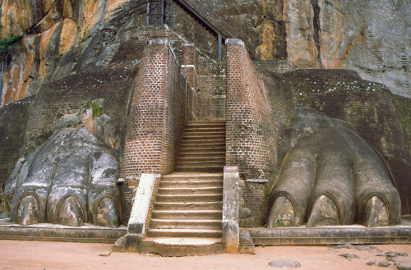
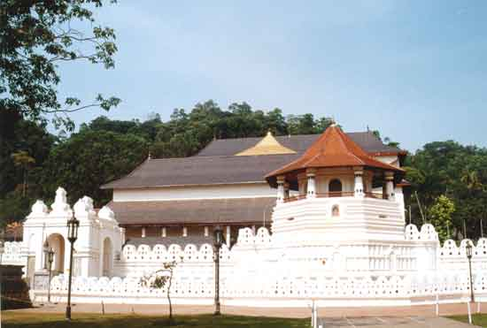

KANDY
Kandy is Sri Lanka's second city and the cultural capital of the Hill Country. In itself it is a vibrant town, more friendly than frenetic Colombo, while its history means that this is one of the most revered towns in the country. This was the last home of the Sri Lankan kings and its many fine buildings bear testament to its status as royal city. It is oriented around a massive central lake, built by Sri Wickrama Rajasinha, the last king to rule here. You can still see the ruins on the island in the middle, which according to local rumour was where the king would invite his favourite handmaidens to come "bathing" with him.

The Temple of the Tooth stands just by the lake. Kandy's premier attraction, it contains Sri Lanka's most valuable Buddhist relic, a tooth of Lord Buddha, smuggled from his funeral pyre and carried to Anuradhapura in secret. Twice daily the tooth (encased within its golden receptacle) is revealed to the devout. The shrine room and the stuffed remains of Raja, an elephant that served the temple for 50 years, can be seen here. If you're in Kandy in July you may see the Esala Perahera, a huge pageant that sees the tooth paraded around the city on elephant back.

SINHARAJA FOREST RESERVE
The most famous nature reserve in Sri Lanka the Sinharaja Reserve is a UNESCO world heritage site and is rightly one of the must-sees for any visitor interested in Sri Lanka's natural as well as cultural heritage.

Located in the south-west of the island the reserve covers an impressive 20,000 hectares. Within its expanse you can find all the diversity of Sri Lanka, whether plant, animal or insect. More than half of the plant and animal life is indigenous to the island, and of that there are several unique species that aren't found anywhere else on earth.

The reserve is one of the few parks in the country where you are allowed to trek on foot, although you should keep an eye out for leeches who thrive in the humid conditions and latch on to any unsuspecting ankles that come along. More interesting is the myriad colourful birdlife, and the great many large mammals you can see within the reserve, including bats, boar and big cats. You can also expect to see reptiles, snakes, large spiders and other insect life, which might be less welcome.

The best point to enter the park, and the most easily accessible from Colombo, is Kudawa, in the north-west of the park.

PINNAWELA ELEPHANT ORPHANAGE
The elephant orphanage, founded in 1975, is a charitable organisation originally funded by the government who were prompted into action by the high number of lone baby elephants orphaned by increased hunting levels. Since the initial group of five elephants the sanctuary has grown remarkably, and there are currently over 70 animals under its protection. The orphanage has also moved several times, as it has constantly outgrown its previous homes.

The current location at Pinnawela near to Kigalle is extensive enough to allow the animals to roam relatively freely, forming their own herd groups and behaving largely naturally. Twice a day the animals are watered in the river and the younger animals are bottle-fed milk, always the most popular visiting time for tourists. The orphanage also boasts plenty of craft shops selling leather, batik and wood carvings.

COLOMBO
It is a sprawling expanse that mixes colonial influences with ultra-modern edifices, and although it can be frustrating and crowded at times, it is always fascinating.

Colombo is split into several separate parts. The central area is Fort (where the Dutch originally had their main stronghold in Sri Lanka) and the Pettah. The massive towers of the World Trade Centre makes it easy to locate these two neighbourhoods, although the town below these modern edifices is completely at odds with their gleaming appearance. Fort is a slightly rundown maze of ex-colonial buildings and banks, while the Pettah is a crowded, crumbling district of narrow streets, packed with hawkers and shoppers. The Dutch History Museum here contains plenty of artefacts from the days of colonial rule and is worth a look.

Elsewhere in the city you can find the modern attractions of the Galle Road, lined with hotels, malls and Western style stores. Nearby you'll find the excellent National Museum, housed in a colonial style mansion and packed with treasures from Sri Lanka's many historical sites. Places of interest in Colombo are Vihara Maha Devi Park and the colonial style brilliant white Town Hall; the Museum which houses many rare treasures; the parliamentary complex at Sri Jayawardhanapura, the administrative capital, a unique work of architecture set on an island. The Bandaranayake Memorial International Conference Hall with its spacious gardens and right opposite is the colossal statue of Lord Buddha. Galle Face Green; the Zoological Gardens – reputed to be one of Asia’s finest; handloom & handicraft shops.

GALLE
The capital of the south coast, Galle is a charming colonial-era town. Established by the Dutch as a coastal fortress it still retains a lot of that nation's laid-back attitude, and is considered more relaxed than the rest of Sri Lanka.

Popular with sun seekers it sits at the heart of Sri Lanka's best beaches, and up the coast, between here and Colombo, you'll find the island's largest resort complexes. Naturally the sands and warm ocean are a tempting draw, but it's worth taking time out from topping up your tan to explore Galle itself. The 17th-century Dutch Fortress is one of the best surviving examples of that particular era in Sri Lanka's colonial history. The National Maritime Museum located here is a small collection of artefacts relating to Galle's nautical and fishing history. The coast here is very popular with divers, the warm clear waters are littered with 17th-century wrecks of Dutch merchant ships from when Galle was an important spice port. Surfers head for the nearby resort of Hikkaduwa, while those wanting to laze on the beach will find plenty of white sand and clean waters at Unawatuna.

NUWARA ELIYA AND THE TEA PLANTATIONS
Head for the hills in central Sri Lanka to see the country's most famous export, tea. Starting from Kandy the tea plantations carpet the slopes of the mountains, rising all the way up to the highest points on the island, well over 2,000m in height. Designated lower, middle or high grown the cooler climate and steady rainfall is ideal for growing the hardy plant, first introduced by the British in the 19th century.

Tea plantations litter the mountainsides and along the road between Kandy and Nuwara Eliya you'll find several offering tours and demonstrations of the tea-making process - the largest is the Labookellie factory owned by Mackwoods, but there are plenty of others.

Sri Lankans refer to the charming town of Nuwara Eliya as "Little England". At 2,000m above sea level the climate here is similar to that of the European nation, and it is no surprise that many British chose to build their homes here when they settled in Sri Lanka. The town contains many examples of British colonial buildings, and even a golf course. Staying in one of the many old-fashioned hotels, waited on by immaculately white-coated attendants, it is easy to transport yourself back to the days of colonial rule.

RATNAPURA
The "City of Gems", which has a reputation for producing some of the world's finest gems, is just one and a half hours away from Colombo. Visit the gemming area, panning of gems, watching men at work with their age-old customs and rituals. Experience the thrill of unearthing a priceless treasure. Visit a gem cutting and polishing centre and the gem museum. View an exhibition of Sri Lankan Gems. Visit the gem museum where you could see a scaled down model of a typical gem pit, showing the different strata of rocks. They will also demonstrate the equipment for the various stages of polishing and cutting of a gem. You will see the transformation of a small stone plucked out of earth, to the sparkling status symbol on your finger.

BENTOTA
Bentota is a famous beach resort at a distance of 62 km to the south of Colombo. Located at the junction of Bentota River and the sea the place offers plenty of water sport opportunities such as windsurfing, water-skiing and catamaran rides. The best time to visit Bentota is between October and April, when the sea is safest for swimming.

BERUWALA
Located at 58 km south of Colombo, Beruwala takes an hour's drive from Colombo to reach. Beruwela marks the beginning of 130 km stretch of South Coast beach resort. It is located close to the famous tourist spot of Bentota. Beruwela is the first Muslim settlement in Sri Lanka, established by the Arab traders in 8th century AD. There is a famous Muslim mosque at the beachhead close to which is a lighthouse. Beruwela has excellent water sport facilities. Beruwela offers good bathing facilities round-the-year.
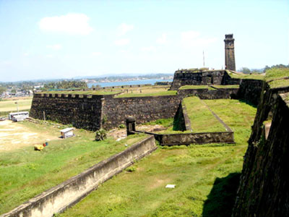
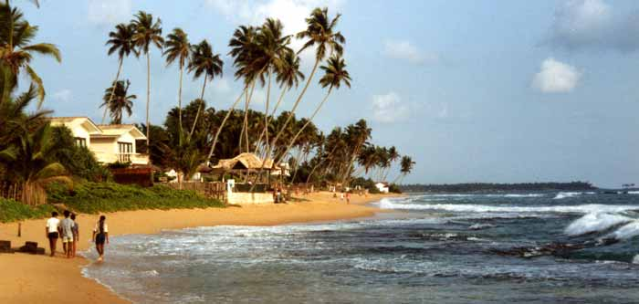

HIKKADUWA
Located 98 km south of Colombo, Hikkaduwa is one of the most popular beach resorts of Sri Lanka. Sri Lanka's only marine sanctuary is located here. It is an ideal place for nature lovers with its abundant corals and tropical fishes. Hikkaduwa has something to offer to everyone-coral for snorkellers, waves for surfers and white pristine beaches for those who want to relax and enjoy Sun and sand.

SHOPPING
Most famously Sri Lanka is home to a thriving gem industry and almost every street (certainly in Colombo and the gem capital of Ratnapura) has at least one jeweller. Traditional jewellery designs aren't always to Western tastes, with overly large gems often used, however some of the more respected jewellers are beginning to change designs to encompass more progressive tastes. The pale sapphire is the island's most distinctive stone but rubies, amethyst, garnet, cat's eye and yellow sapphire are all widely available. It is possible to simply buy stones as well, which can be set when you return home. Many larger jewellers offer small tours of their workshops as well as the opportunity to buy.

Miscellaneous items to look out for include brass ornaments, leather, silverware, spices and of course tea. Tea factories and processing plants always have a shop selling smart gift sets of top quality and flavoured tea but prices are more competitive at supermarkets. You only need to buy the rarest varieties from source.

Kandy is the best place to buy most of the handicrafts produced in Sri Lanka. There are number of shops catering to the tourists. Markets such as Kandy's large bazaar are the cheapest place to shop, but even here tourist prices will be marked up. At Kundasale, about 4km from Kandy, a village has been established recently to settle local craftsmen and their families. Visitors could watch artisans at work and purchase their products on site.

Sri Lanka is a major garment manufacturer and exporter of all kinds of clothing. Colombo is a major attraction for garment hunters. One can buy excellent selection of children's wear, beach wear, casual clothing for men and women and warm padded jackets at attractive prices from Colombo.

As the producer of the world's finest teas there are many tea sales centers at most tourist destinations around the country and at main shopping centers in Colombo.
If you think something is grossly over-priced then imagine it in your local department store and state what you think it would be priced there - it is guaranteed to be far more than the vendor could expect to receive for the piece. That way everybody gets a fair deal.

Opening Hours
Shops tend to open from around 09h00 until 19h00 or 20h00 each night. Many will close in the middle of the day for a siesta. Markets and grocery stores may open earlier.

LIST OF INDIAN RESTAURANTS

- ALHAMBRA HOLIDAY INN
30 Sri Mohamed Marcan Marker Mawatha, Colombo 2

- BANANA LEAF
86 Galle Road,
Colombo 4

- CURRY BOWL
24 Deal Place,
Colombo 3

- CURRY LEAF HILTON
Echelon Sq, Lotus Road,
Colombo 1

- AMRITH INDIAN RESTAURANT
No.17, Dickmans Road,
Colombo - 05

- CURRY LEAVES
68 W. A. Silva Mawatha,
Colombo 6

- RAJA BOJUN
Ceylinco Seylan Towers,
Galle Road (opp. Oberoi),
Colombo 3

- ROHANS NORTH INDIAN
99 Union Place,
Colombo 2

- SHANTI VIHAR
Havelock Road,
Colombo 5,
Tel: 58 0224

- SHERE PUNJABI
121A Galle Road Dehiwala,
Colombo

- SOCIETY
Airport Garden Hotel, 234-238,
Colombo-Negombo Road Seeduwa,
Colombo
Tel: 11 2 253771 4 / 252950 5

- TANDOOR CEYLON CONT
48 Janadipathi Mawatha,
Colombo 1

- THAMBAPANNI ISLAND
496/1 R.A. De Mel Mawatha (Duplication Road),

- WALAUWA
5th Level, Access Towers, 278,
Union Place, Colombo 3

